RESUME

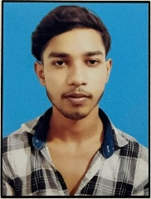

**AYUSH KUMAR PRASAD**

**MOB : +91-9142540770**

**Email :-** [**bhartiayush261@gmail.com**](mailto:bhartiayush261@gmail.com)

**CAREER OBJECTIVE:-**

* To have a Career in a professional organization with my discipline honesty and hard working for Achieving Target.

**ACADEMIC QUALIFICATION:-**

* 10th Passed from Bihar Board in 2022
* 12th Passed from Bihar Board in 2024
* Currently pursuing a Bachelor’s degree (BCA) in computer science in GALGOTIAS UNIVERSITY

**SKILL:-**

* C C++

**PERSONAL DETAILS:-**

Father’s Name : Mr Shambhu Pasad

Date of Birth : 18 November 2006

Gender : Male

Language : Hindi & English

Marital Status : Un-Married

Religion : Hindu

Permanent Address : Vill. Chaube ki Chauni Near Agaion Bazar Post .

Agaion Bazar Dist . Bhojpur (BIHAR)

**DECLARATION:-**

* I hereby certify that all the information provided here is correct to the best of my knowledge and belief.

(AYUSH KUMAR PRASAD)